**Hyperledger Assignment**

* As per requirement, screen shot of changed in Fabric Code & deployed

1. This is the testAPI.sh call for the changed gadget API calls for addGadget, queryAll, changeGadgetOwner and queryAll again.

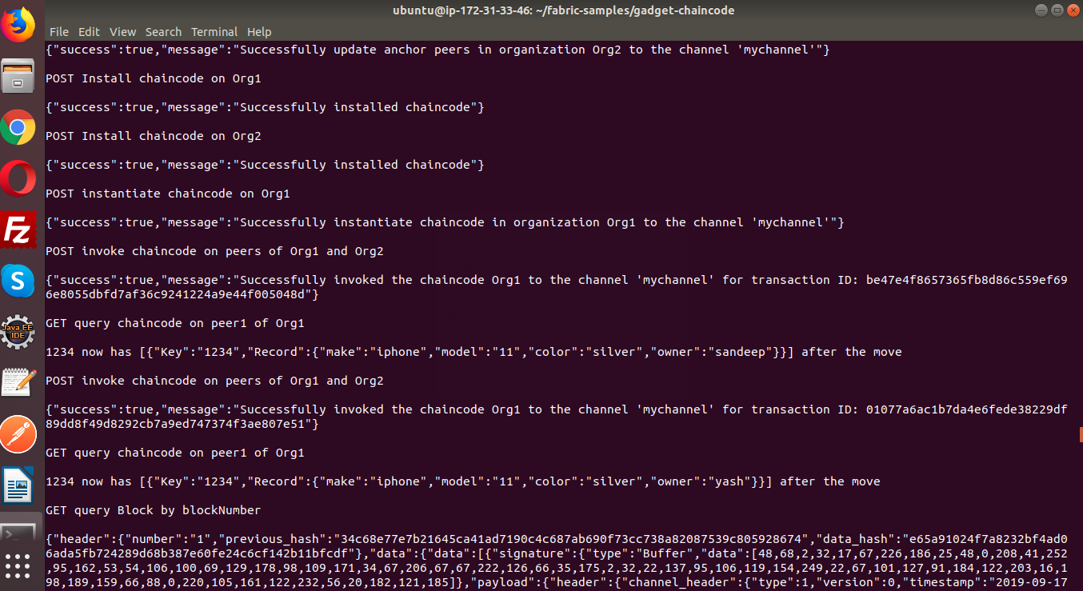

1. This is the runApp console for gadget hyperledger chaincode runtime.

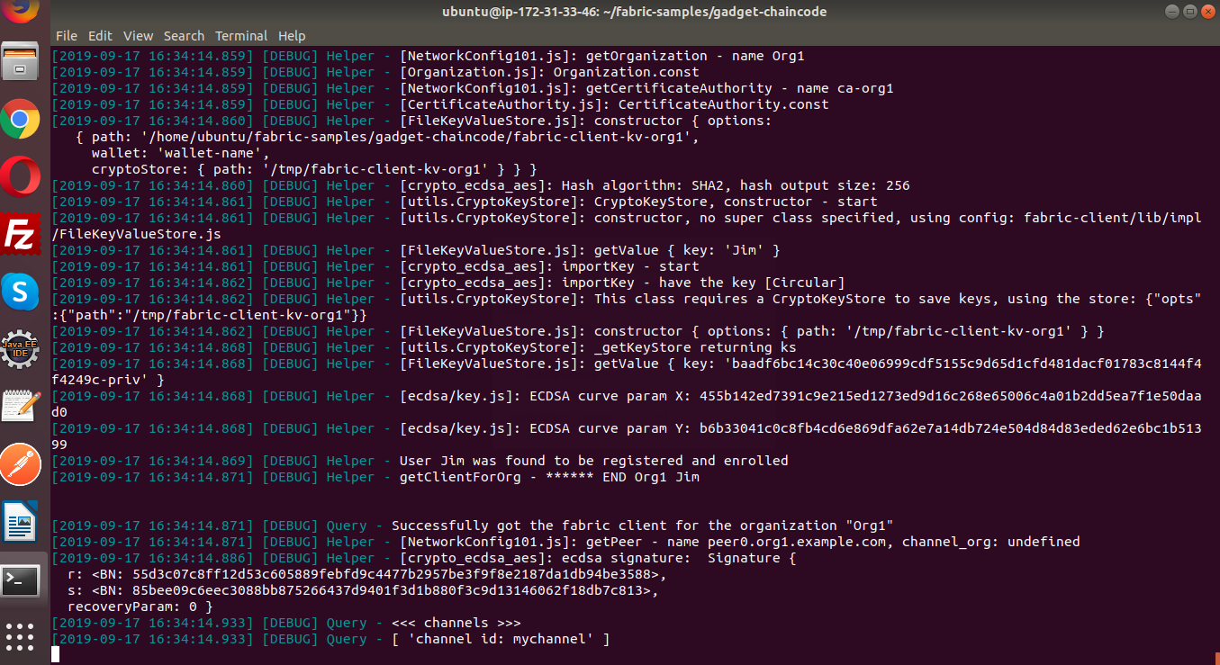

1. Its queryAll call executing on the hyperledger console

